

Using technology to improve healthcare in africa

How will a universal EMR improve significantly diagnostics and help avoid pandemics in Sub-Saharan Africa



Djibril Sall

Products & Processes Quality Technologies

Professor P. Garrett, P.E

ENGR7025

5 December 2017

Table of Contents

1 ABSTRACT 1

2 OBJECTIVES 2

3 HEALTH CARE PROBLEM IN AFRICA 3

3.1 MEDICAL FACILITIES 3

3.2 LACK OF MEDICAL EQUIPMENT 5

3.3 LACK OF A GOOD STRUCTURE 5

4 USING TECHNOLOGY TO IMPROVE THE HEALTHCARE SYSTEM 6

4.1 AN EMR SOFTWARE 6

4.1.1 STATISTICAL INFORMATION AND APPOINTMENTS 7

4.1.2 GIVING PEOPLE ACCESS TO RELIABLE SERVICES 8

4.1.3 ISSUES THAT NEED TO BE ADDRESSED AND SOLUTIONS FOR THE EMR 9

4.2 Regional Laboratories 9

5 Conclusion 10

Bibliography 11

# ABSTRACT

According to an article from the UN published in the UN news article published in 2006, the life expectancy in Sub-Saharan Africa has dropped by 30% (UN News Center, 2013). This hasn’t improved that much during the past 11 years as the countries with the lowest life expectancy are located in Sub-Saharan Africa. This is due to a number of problems, one being the lack of good health infrastructures as well as technology but also poverty in those countries. We are going to assess some of those problems as well as their causes. Secondly, we are going to see how we could use technology to improve the healthcare system and help all the populations to have access to a healthcare system that will not only be able to prevent some pandemics from occurring as well as improving the whole system used there now.

# OBJECTIVES

The Goal of this study is to underline a few problems that are affecting healthcare in Africa and how we could use a simple system like a centralized sever to improve it significantly. A lot of diseases that has been eradicated in the first world countries remains active in African countries and kill millions of people every year. It’s the case of Malaria as well as several other diseases which remains really present in Africa as that 90% of malaria cases around the world are in Sub-Saharan African countries (Snow, 2006) . The mortality for this disease is higher among young kids who live in rural areas (figure 1). This has been happening for the past 60 years and no significant solution has been found. It’s also true for other less common diseases like Diabetes and Kidney failure that has been haunting the continent during the past two decades. This is not only due to the difficulty of being able to detect these diseases when they start, but also difficulties on how to remediate or provide the right care to the population when one is affected. The same applies to stopping epidemics that are more dangerous since nowadays with Globalization they can spread exponentially.

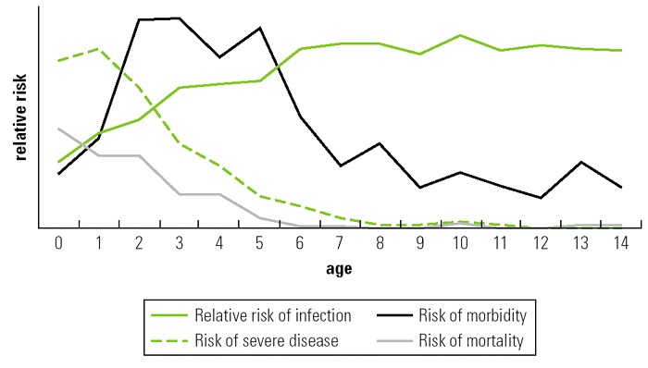

Figure

In the second part of this paper, we are going to how creating an electronic system can help easily gather statistical information about diseases as well as putting in place some actions to prevent them from happening in the future. This could also help easily detect epidemics before they spread across the country or the world. This could also easily facilitate diagnostics as facilities without the required medical equipment’s could send samples to other laboratories and receive the results electronically. We are going to first elaborate about the problems, then give the solution we are proposing and how much improvement we think it would bring.

# HEALTH CARE PROBLEM IN AFRICA

There is a lot of problems that surrounds the healthcare system in Africa. Some of which are due to the lack or insufficient amount of infrastructure, sometimes some of these infrastructures lacks don’t have the technology or the equipment’s to conduct their jobs and lastly the way they are managed and the lack of statistical information make It hard to remediate some of these problems.

## MEDICAL FACILITIES

According to the World Bank 62% of the population in Sub-Saharan Africa live in rural areas *(Figure 2).* That’s an estimated population of 630 million people, most of these population leave in poverty and often lack access to basic needs like clean water and also to a good hospital they could turn to when they are sick.

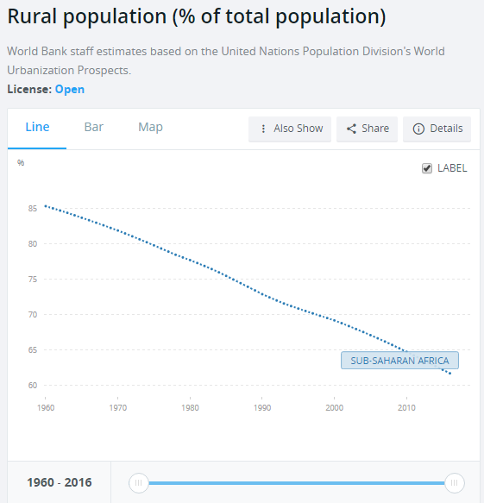

Figure

These people are often more exposed to diseases given that almost all of them work in agriculture and usually encounter insects or consume non-clean water that exposes them more.

When one of these people get sick, the main issue they often face is finding a hospital to go to to receive care. Being the second largest continent in the world with a population of 1.2 Billion people, the different countries in Africa due to their limited resources face enorm difficulties to build enough Medical facilities close to the populations living in rural areas. People often have to travel miles to find a small health center who might them refer them to a nearest district hospital as Molyneux Elizabeth and Weber Martin found in their study conducted in Kenya (Molyneux & Weber, 2004). This often lead to some people just deciding to just take whatever they get from the small district or decide to go with traditional solutions due to the fact that they can’t afford to travel 50 miles to the nearest district Hospital. This lead sometimes to people being untested for some diseases and not being able to get the care they deserve or need. Often when one is able to get to the nearest district Hospital the problem they might face is the lack of medical equipment to conduct some tests and might get referred to go to clinics in the Capitals or bigger cities.

## LACK OF MEDICAL EQUIPMENT

This is one of the biggest issue faced by medical facilities in places outside the capitals in Africa. Most of these doctors are often left to only perform diagnosis with information they get from the patients themselves and what they can visually identify. This often leads to misdiagnosis as well as making it impossible to identify some diseases that needs further testing to be identified. Most of these hospitals don’t have urinalysis devices or any way of testing sample bloods. Performing a Urinalysis alone can provide substantial information about one’s health as it can help diagnostics urinary tract infections, kidney disorders, liver problems, diabetes or other metabolic conditions. The adaptation and usage of these device could significantly improve and help diagnostics some of the chronical illnesses that kills millions of people every year in Africa. This was confirmed by a survey conducted in Mozambique in Hall Thomsen’s journal article where they found that in that country only “18% of health facilities surveyed, ketone testing strips in 8% and blood glucose meters “(Hall, Thomsen, Henriksen, & Lohse, 2011). The same is also true for blood sample testing to find often more damaging illnesses especially transmissible infection diseases such as HIV. In sum the main issue that most of these hospitals faces is that they don’t even have the adequate equipment to find such vital information that could help them save lives. These aren’t even advanced equipment like MRI’s or Chemotherapies equipment rather these are readily available cheap devices that every medical facility should possess. Besides these fundamental problems that Africa’s healthcare system faces, the other category of problem consists of the lack of information as well as some issues in how the facilities are managed.

## LACK OF A GOOD STRUCTURE

The last set of problems are due to the way those medical facilities are even organized. Even though all African countries have disease control and prevention organization most of them have a hard time gathering information from individual medical centers as they are all located far apart from each other and don’t often have other than a paper and pen to record it. Some of these hospitals often faces shortages in staff which prevents them from having the resources to conduct documentation of visits. Having this information could not only help identify pandemics before they expand but also identify the number of people who need care in a certain area and provide them with enough personnel or equipment they need. This lack of documentation also prevents from knowing the real statistics of the mortality caused by certain diseases as most of the statistics we get in those areas are based on “Verbal autopsies” (Streatfield, et al., 2014).

The other issue people usually face is that they don’t have any appointment scheduling system and people usually show up without knowing if the doctor will be able to see them or not. This can be sometimes frustrating as some people would not want to go to the hospital for the simple fact that they don’t want to be standing in lines for hours then having to go back home after several hours. This last category isn’t just something that hospital in rural areas faces but also hospitals in big cities. We also have corruption with some people managing those facilities embezzling money from those organization.

We are going to elaborate on how with the accessibility of computers nowadays and different technological advances can help us find solutions for these health organization.

# USING TECHNOLOGY TO IMPROVE THE HEALTHCARE SYSTEM

Throughout the last 10 years computers have become more and more powerful but also affordable. Breakthroughs in Wireless technologies also brought network connectivity prices down as well as adding new security layers that can help transfer data securely and in a long distance for cheap. For the solution we will be proposing one will be completely based on an EMR (electronic medical record system) that would help gather information but also find solution to some of the problems the healthcare systems are facing. The second solution will be creating laboratories that will be implemented in areas close to the centers that can be equipped with all the equipment needed.

## AN EMR SOFTWARE

Creating an EMR software is not an easy task as it has not only to include a good security system to protect people’s privacy but also be able to remediate the different issues we want to tackle. These are the 3 different problems that we are trying to fix with the EMR system: gathering statistical information about health relative to areas, regions or countries; making it easier for people to schedule appointments, giving them the possibility to give feedbacks about their experience at medical facilities as well as providing with safe and reliable source of care.

### STATISTICAL INFORMATION AND APPOINTMENTS

A computer based system like the open EMR will make it easy to record medical visits as well as an exact record of different symptoms or cases of a certain diseases in an area. Having an option for appointment scheduling will make it easier for people to schedule appointments, but also with electronic payments, money that was susceptible to embezzlement. These systems are often intuitive and easy to use. Even if they represent an extra step for the Dr. it will improve the quality of service they providing to the patient. In one click, they can have access to all their medical history as well as the previous encounters they had with that Dr. or any previous Dr. This will be a good way to prevent epidemics from spreading as the system could issue flags when it detects an unusual amount of certain cases and the authorities could take measures its spread. This would also help situating responsibilities in case of a mal-practice.

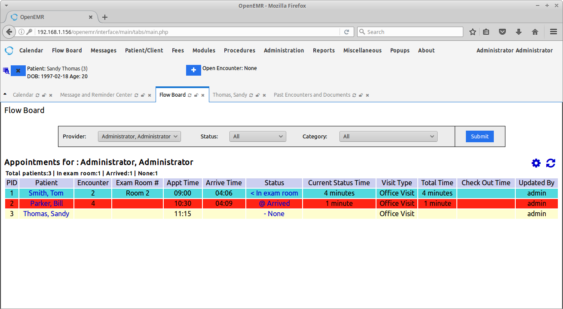

Figure

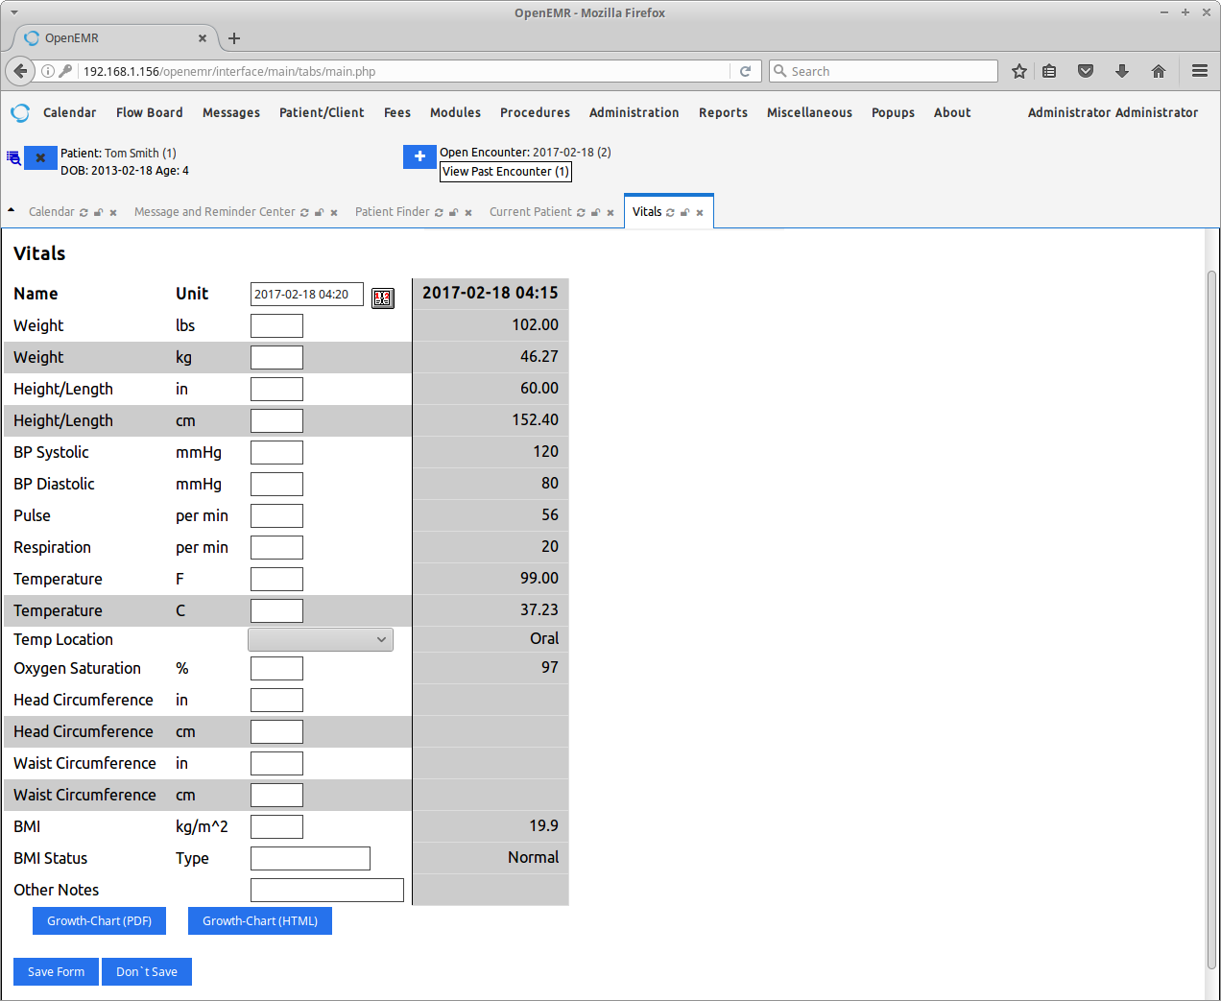

Figure (Vitals Record Page)

This will also help Dr. remind the procedures when they are examining a patient. With the EMR we will be moving from getting inaccurate information based on surveys conducted at sometimes to getting accurate information in real-time.

### GIVING PEOPLE ACCESS TO RELIABLE SERVICES

One of the main problem people come across sometimes in the healthcare industry in Africa is going to services that are not reliable or that don’t provide a service of quality. With a the universal EMR it will be easy to classify the different organization based on their services but also electronics records can be significant proofs if a Dr. or Hospital violates any law. In the past decade, a lot of pharmacies has been caught reselling expired medicines as well as sometimes medicines from China that are not good for consumption. With this EMR we, will make sure that only Pharmacies that have all their certifications can receive the prescriptions.

### ISSUES THAT NEED TO BE ADDRESSED AND SOLUTIONS FOR THE EMR

One of the fundamental issue that EMR projects must face in all the countries in the world is the issue of privacy. In order to solve that problem, we can implement a two-factor authentication which will only give a Dr. access to one’s medical record by getting an authorization by text or email from that person. This can be a good solution for preventing unauthorized access to medical records. Another problem that have been happening for the past few years has been attacks from hackers who steal information and ask for ransoms. The only way to escape from those kind of attacks is by isolating all the computers that can access the EMR from the internet by connecting them only to the EMR servers. Nowadays with WIMAX technology, it has become extremely cheap to get directional antennas that could send information easily for 50 miles. Isolating the network and creating a mesh network between hospitals will be the easiest way to protect the system.

## Regional Laboratories

The Government could build different Laboratories or testing centers in each region. Where hospitals will be able to send blood samples or any sample that need testing and using the EMR the results can be automatically uploaded in the system. This will reduce the need of people traveling to travel just for tests. Some of these hospitals are also located in remote areas and with the accessibility of drones nowadays, these samples could be easily transported from those areas to the laboratories. This would significantly increase the early detection of infection as well as other disease and it will potentially save lives. These laboratories can also be used as research facilities for the development of new medical devices. The reality is that medical equipment are extremely expensive and one thing that could help significantly these countries is developing their own technologies. Which will result in producing cheaper alternatives that could be placed in all the medical facilities. These labs could also help the public health system generate more money that now. As it will increase the amount of people taking urinary tests or blood tests and thus increasing the profit made by the sector. That profit could be injected back in the system to fund researches.

# Conclusion

Implementing this solution will not be something easy as it requires a lot of resources as well as passing a lot of regulations. By building prototypes and doing trials in a region, it will help obtain more information on how reliable it is and exact measurement of positive impact it will have. The implementation of this system will help Sub-Saharan African has access to a good healthcare system. One that will make it easier to have tests conducted and receive the results back electronically. It will also significantly reduce or complicatedly eradicate embezzlement in the public health sector. Having accurate real-time statistics will help in taking actions early when a virus is detected and work on stopping its spread. This will also help the Governments who control all the health organizations generate more money, but also have key information on the number of people who need care and which type of care in order to provide them with more tailored solution. This project will need to be tested in a region so that, we can get more information on how effective it will be.

# Bibliography

Castelnuovo, B., Kiragga, A. N., Afayo, V., Ncube, M., Orama, R., Magero, S., . . . Kambugu, A. (2012). Implementation of Provider-Based Electronic Medical Records and Improvement of the Quality of Data in a Large HIV Program in Sub-Saharan Africa. *PLOS ONE, 7*(12). Retrieved 12 6, 2017, from https://ncbi.nlm.nih.gov/pubmed/23284728

Hall, V., Thomsen, R. W., Henriksen, O., & Lohse, N. (2011). Diabetes in Sub Saharan Africa 1999-2011: Epidemiology and public health implications. a systematic review. *BMC Public Health, 11*(1), 564-564. Retrieved 12 6, 2017, from https://ncbi.nlm.nih.gov/pmc/articles/pmc3156766

Molyneux, E., & Weber, M. (2004). Applying the right standards to improve hospital performance in Africa. *The Lancet, 364*(9445), 1560-1561. Retrieved 12 6, 2017, from https://ncbi.nlm.nih.gov/pubmed/15519614

Snow, R. W. (2006, January 1). *“Malaria.” Disease and Mortality in Sub-Saharan Africa. 2nd edition*. Retrieved from U.S. National Library of Medicine: www.ncbi.nlm.nih.gov/books/NBK2286

Streatfield, P. K., Khan, W. A., Bhuiya, A., Hanifi, S., Alam, N., Diboulo, E., . . . Byass, P. (2014). Malaria mortality in Africa and Asia: evidence from INDEPTH health and demographic surveillance system sites. *Global Health Action, 7*(0), 25369-25369. Retrieved 12 6, 2017, from https://ncbi.nlm.nih.gov/pubmed/25377329

UN News Center, U. N. (2013, November 9). *UN News* . Retrieved from Life expectancy in sub-Saharan Africa is lower now than 30 years ago: UN index: www.un.org/apps/news/story.asp?NewsID=20548